**AWS Task-2**

**Task Description:**

Set up a VPC with an Internet gateway, create a public subnet with 256 IP addresses, a private subnet with 256 IP addresses, make a route table connecting the Internet gateway and the subnets, and launch a Linux EC2 instance by using the above VPC and public subnet.

=========================================================

**Steps**: -

1. Login to AWS account using root user.
2. **Creating VPC** :-
   1. Search “**VPC**“ in search box.

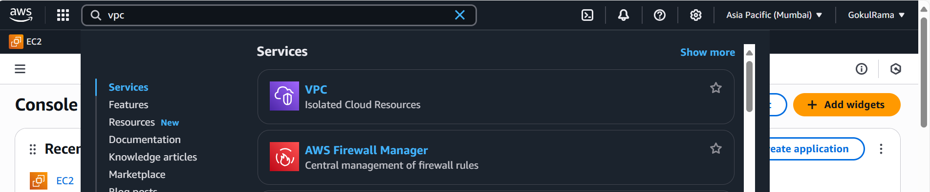

* 1. Click “**Create VPC**“ option.

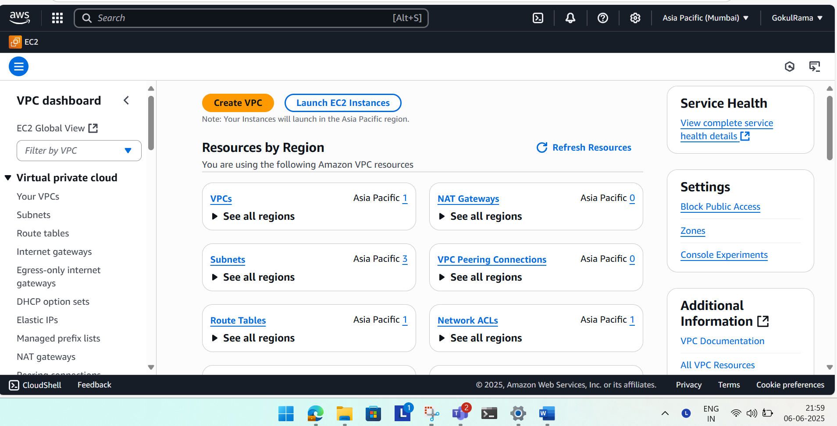

* 1. Below are the VPC settings,
     1. Select “**VPC only**“

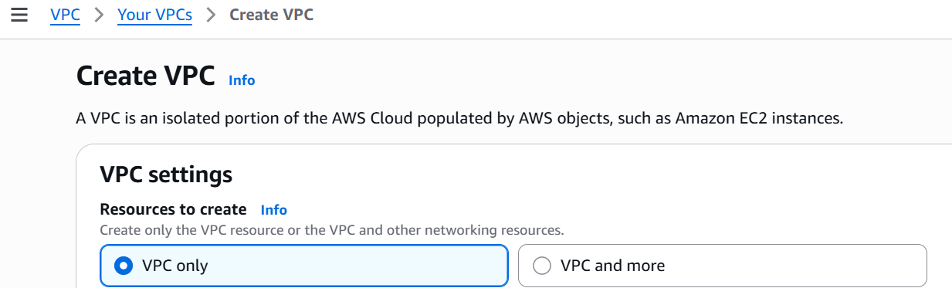

* + 1. **VPC Name - Test_VPC**

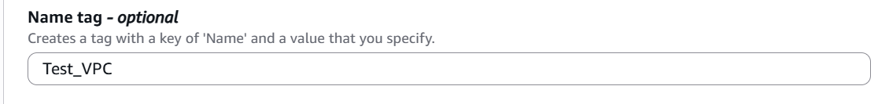

* + 1. **IPv4 CIDR block [ Private IP] is 10.0.0.0/16.**
    2. **IPv6 CIDR block [ Public IP] is No IPv6 CIDR block**
    3. **Tenancy – Choose default.**

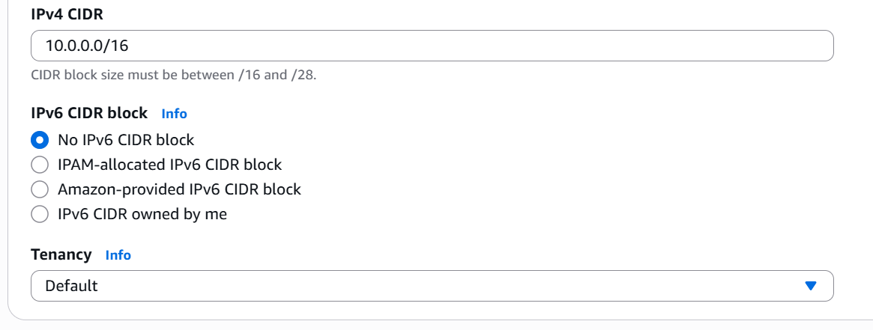

* + 1. **Tag Name is “Test_VPC**“ (i.e.) VPC name for identification.

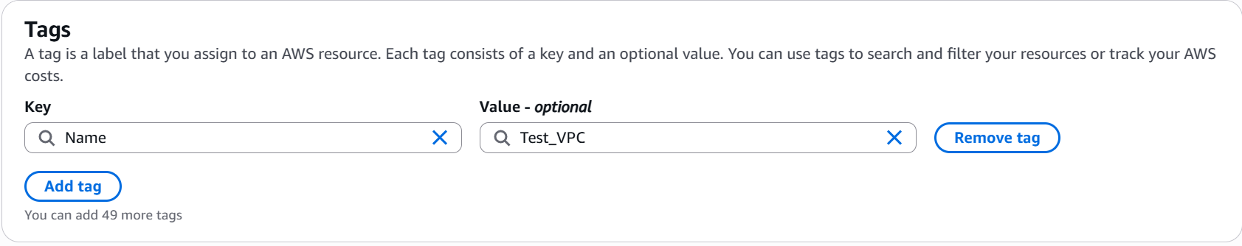

* + 1. Click “**Create VPC**“ option.

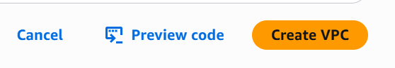

2.3.8 Once **VPC created successfully** it shows like below,

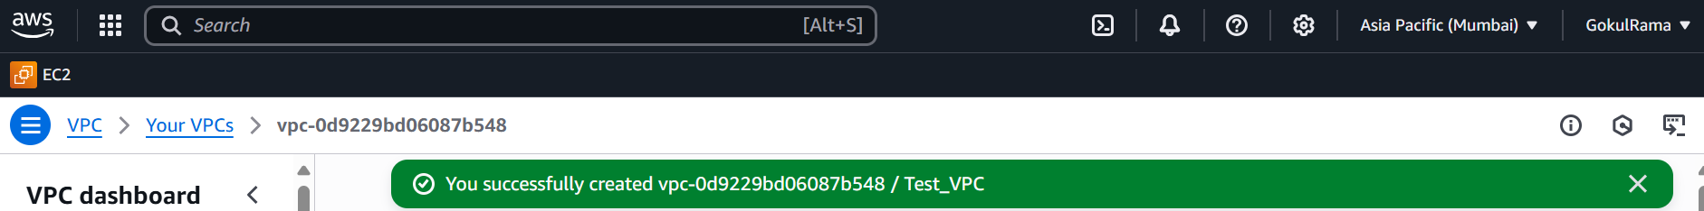

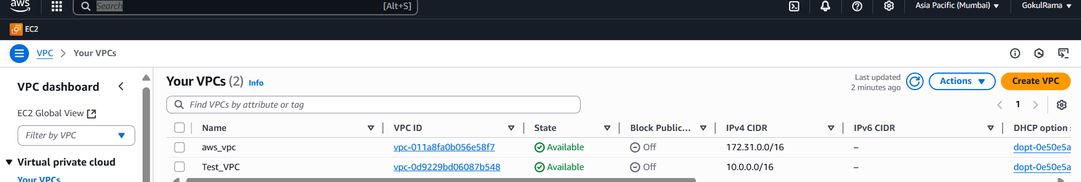

1. **Create Internet Gateway: -**
   1. Go to **VPC dashboard.**
   2. Select the option as **Internet Gateways** in left side.

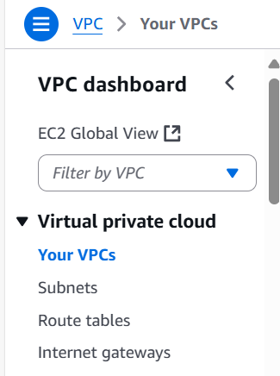

* 1. Already one default internet gateway created by AWS and i renamed it “**aws_IG**”

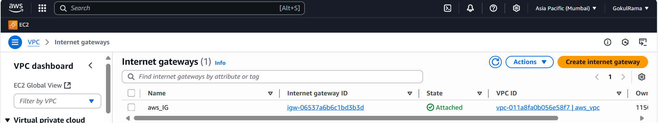

* 1. Select the “**Create Internet Gateway**” option.

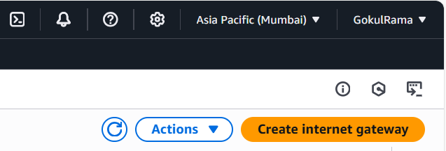

* 1. Name of the **Internet Gateway – IGW_Test** in Name tag.
  2. Give the Tag name as **IGW_Test**
  3. Click “**Internet Gateway**”

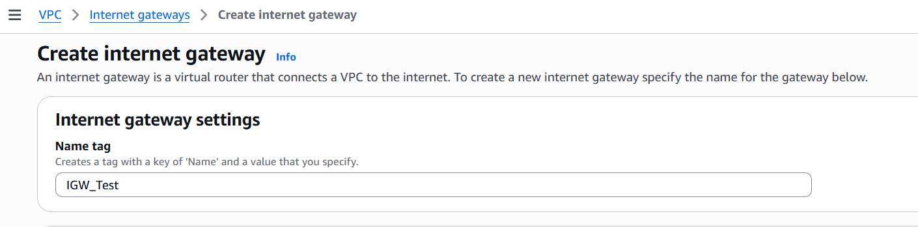

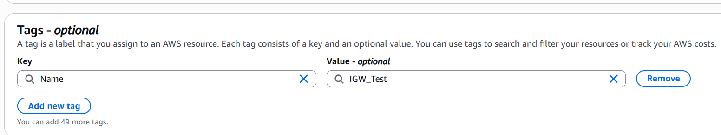

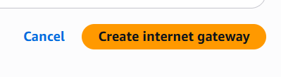

* 1. Once **internet gateway successfully created** it shows like below,

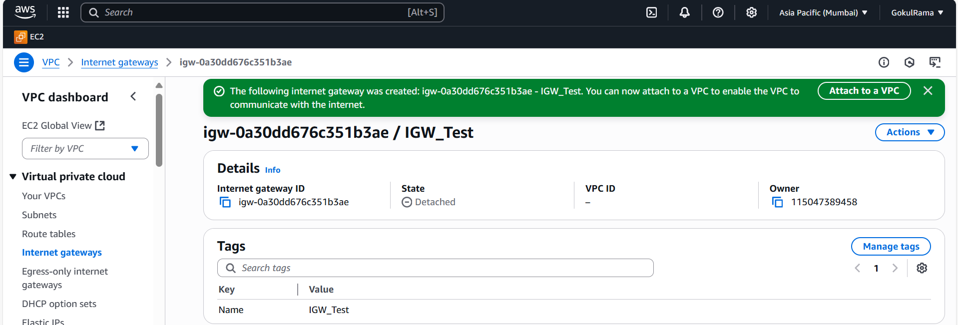

* 1. After created Internet Gateway the “**State**” column is showing as “**Detached**” (i.e.) **Need to attach VPC to internet gateway.**

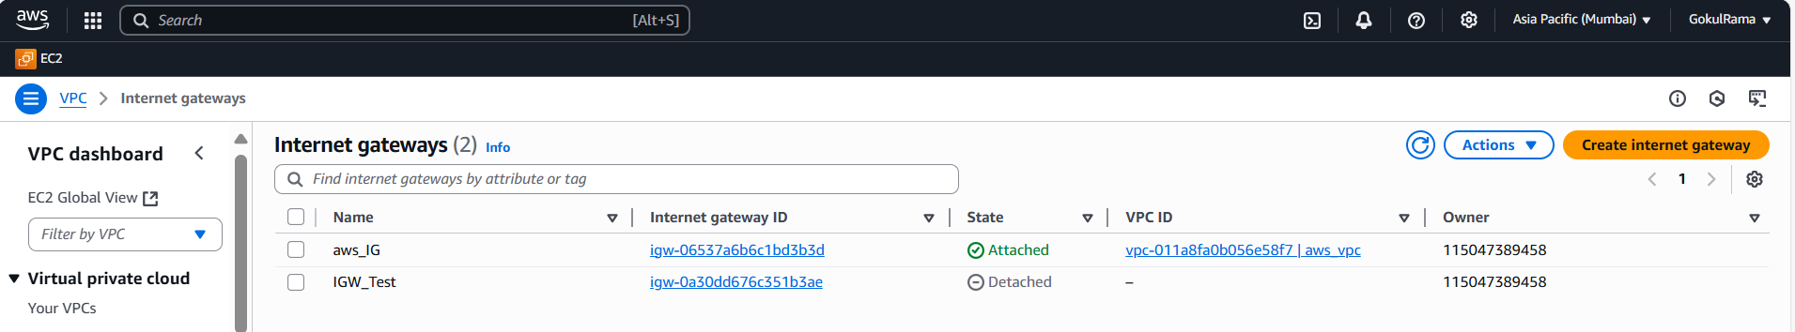

3.10 **Need to attach VPC** to internet gateway, then go to **Actions -> Choose Attach to VPC** option.

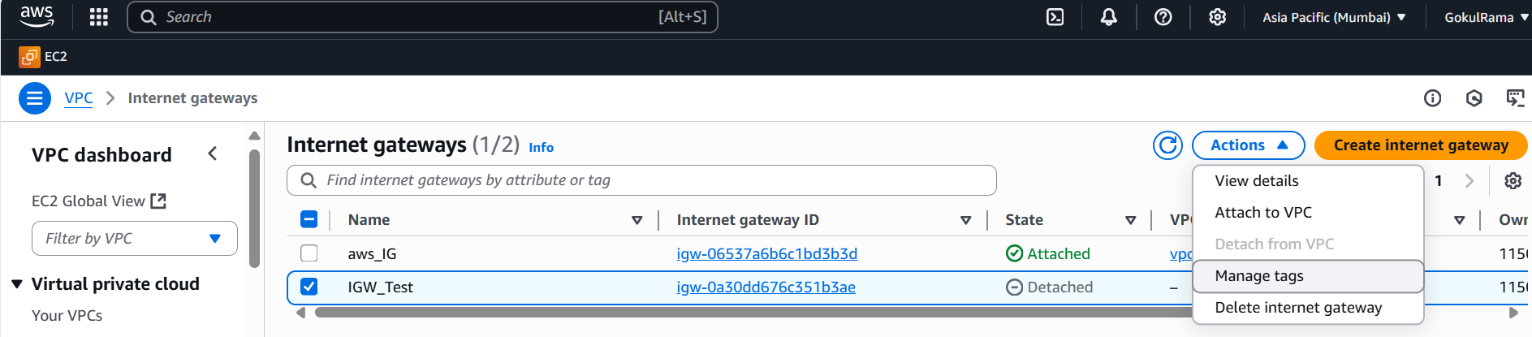

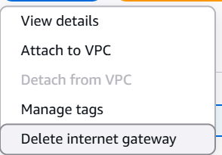

* 1. Available VPCs -> select respective VPC that created above (**VPC Name – Test_VPC**).

Click **Attach Internet gateway.**

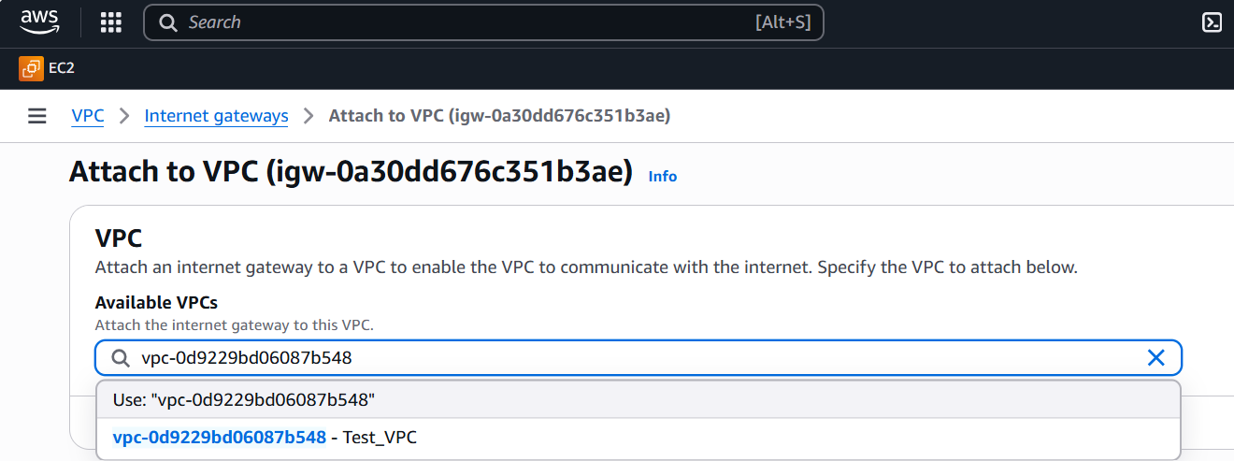

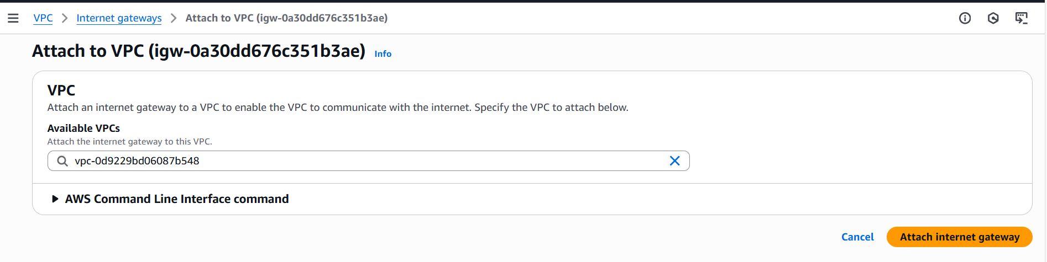

* 1. Once **Internet gateway attached to VPC successfully** then the **status** is showing as **Attached** instead of **Detached** [ Refer the below picture].

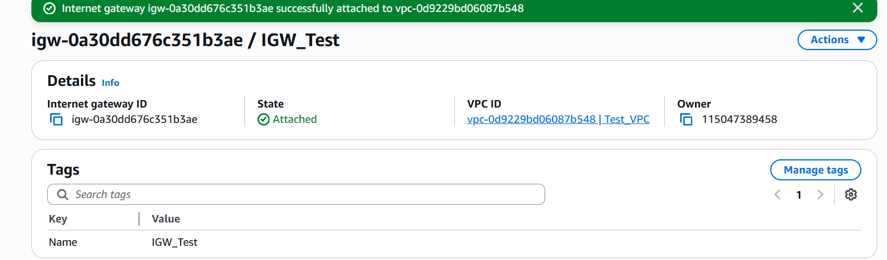

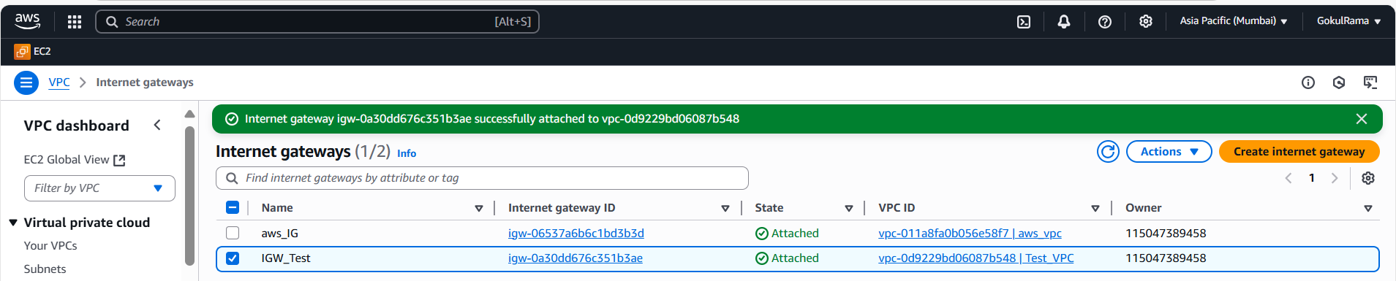

1. **Creating Subnets: -**
   1. Go to **VPC Dashboard** on left side
   2. Click **Subnet** option
   3. We need to create **both Public subnet and Private subnet.**

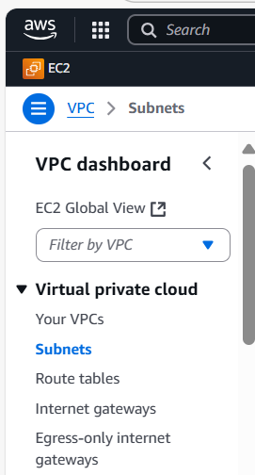

* 1. Already some default subnets available and it’s created by AWS. I renamed it “**default_aws_s1, default_aws_s2 and default_aws_s3” like that. Refer the below snapshot.**

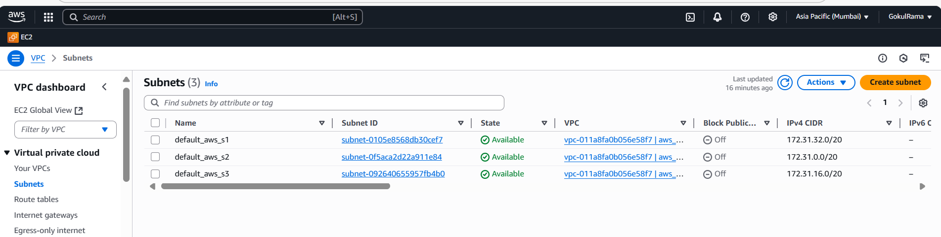

* 1. Select **Create subnet** option.

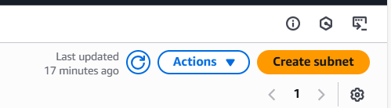

4.6 In **Create Subnet** settings, Choose **VPC** already created above [ VPC Name is **Test_VPC**]

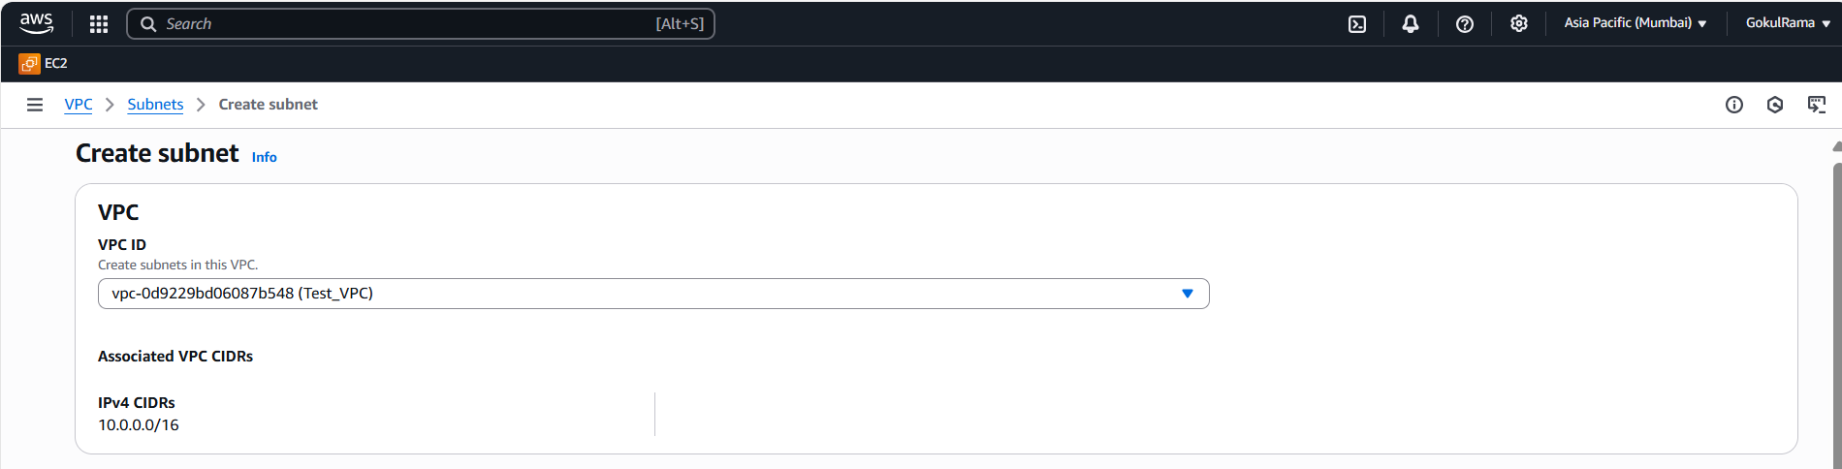

* 1. **Create Public Subnet like below,**
     1. **Subnet Name is Test_Public_Subnet_1a**
     2. **Availability Zone – Based on region we selected and created VPC and it list all availability zones.**
     3. **IPv4 CIDR block – 10.0.0.0/16**
     4. **IPv4 subnet CIDR block – 10.0.0.0/24 [ For 256 IP’s].**
     5. **Give Tag Name is Test_Public_Subnet_1a**

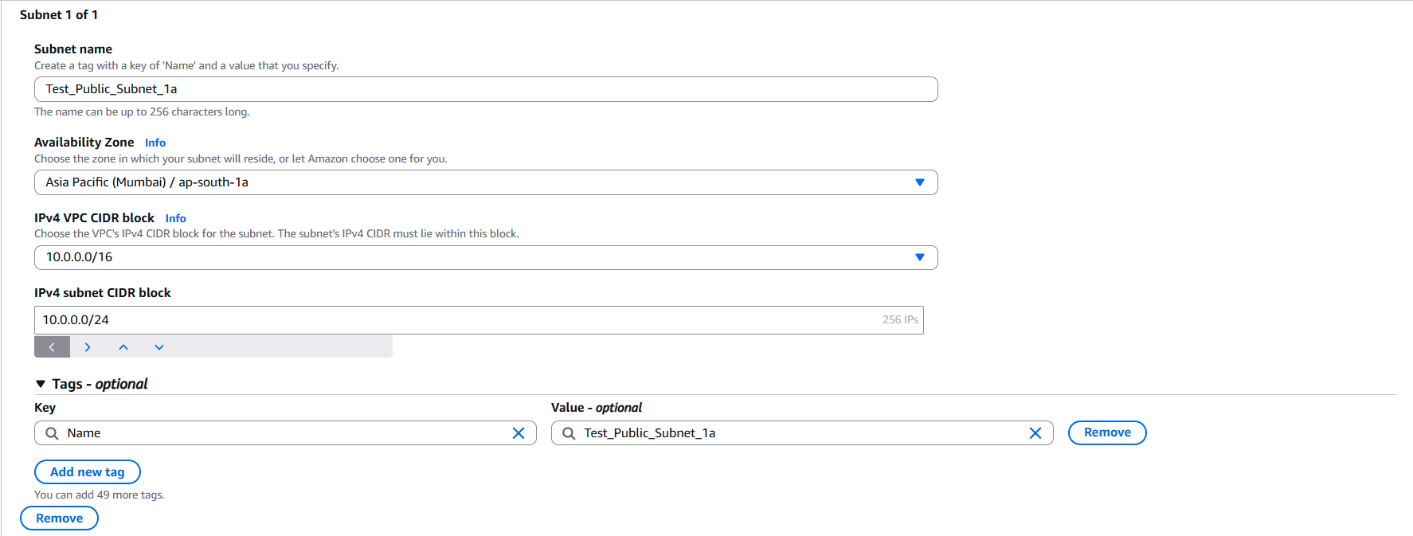

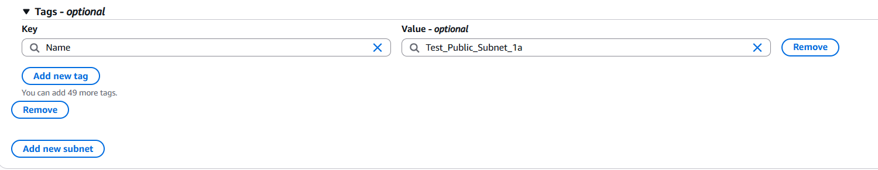

* 1. **Create Private Subnet like below,**
     1. **Subnet Name is Test_Private_Subnet_1a**
     2. **Availability Zone – Based on region we selected and created VPC and it list all availability zones.**
     3. **IPv4 CIDR block – 10.0.0.0/16**
     4. **IPv4 subnet CIDR block – 10.0.1.0/24 [ For 256 IP’s].**
     5. Give **Tag Name is Test_Private_Subnet_1b** and Click **“Create subnet”**

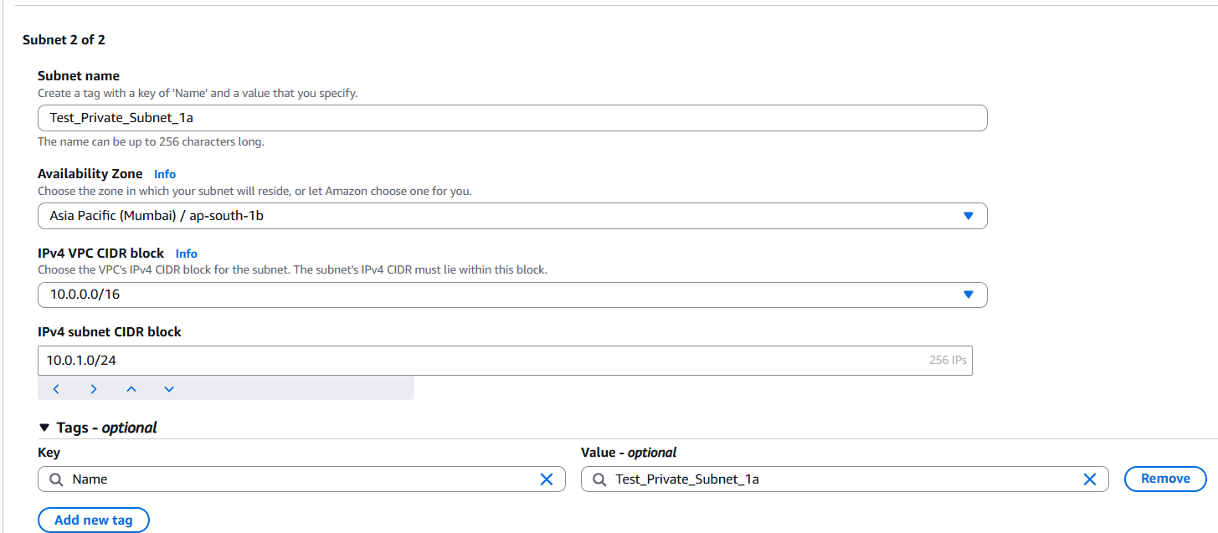



* + 1. Once both public and private subnet created successfully, it looks like

below,

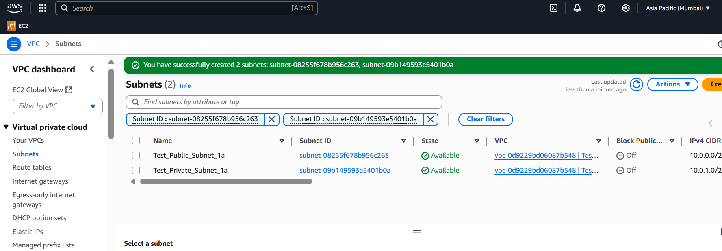

1. **Creating Route Table For Both Public and Private Subnet: -**

5.1 Go to VPC Dashboard

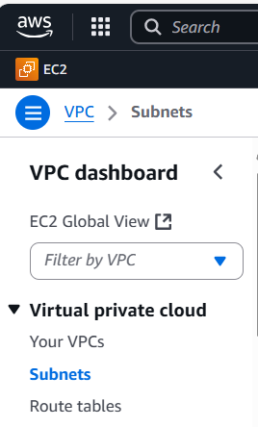

**5.2** In Route table already one default routing table is there its created by

AWS and I renamed it as “**aws_rt1**”

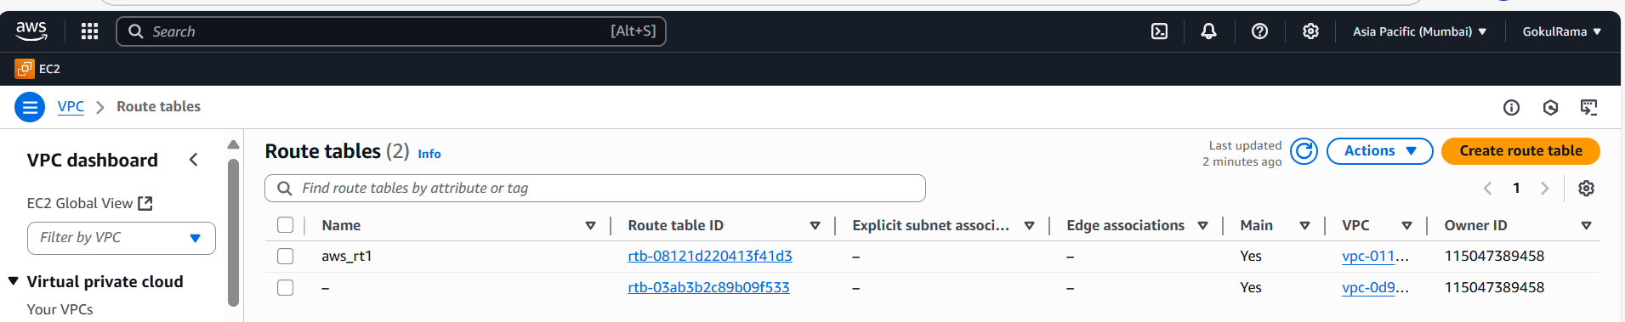

**5.3** Click **“Create route table”**

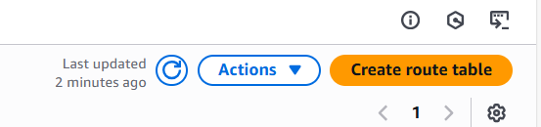

**5.4** Once clicked “**Create route table**” and do the below “**Create route table”**

**Settings for public route**,

* + 1. Name of the route table – **RT_TEST_PUBLIC** in **“Name-optional”**
    2. VPC – **Select VPC (Test_VPC)** already created above.
    3. Tags – Give “Route table” name (Name of the route table is **RT_TEST_PUBLIC**
    4. Click **Create route table.**

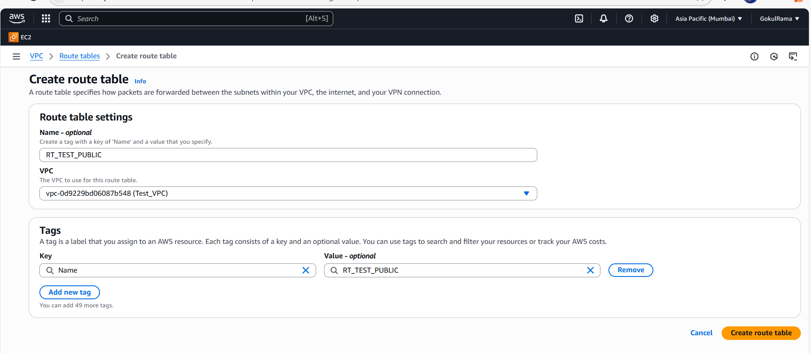

5.4.5 Once public route table created successfully it shown like below,

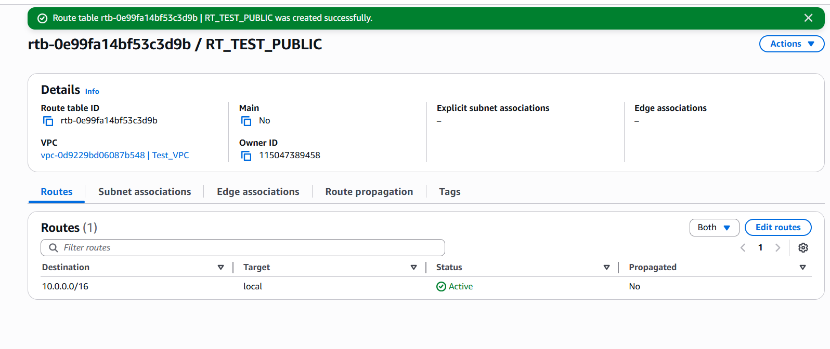

5.4.6 Now add routes to public route table-> Click **Edit routes**

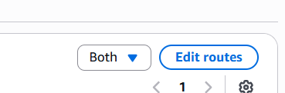

**5.4.7 Click Add route**

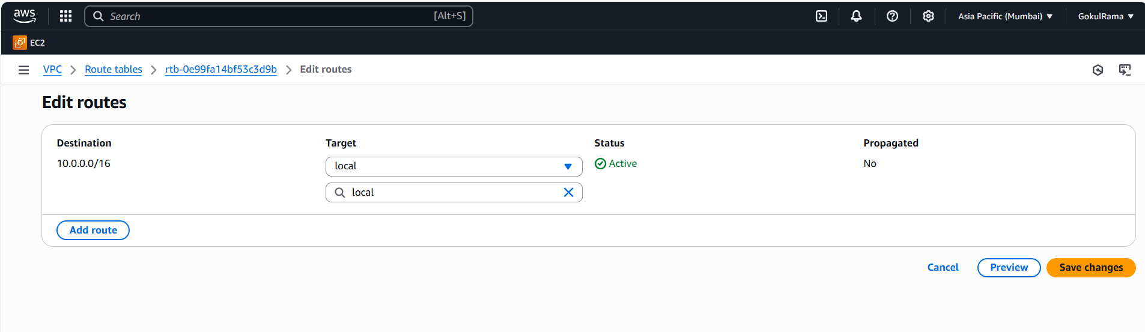



**5.4.8** Enter **0.0.0.0/0** IP to access to the internet and chosen already created

Internet Gateway (**IGW_Test**) -> Click save changes.

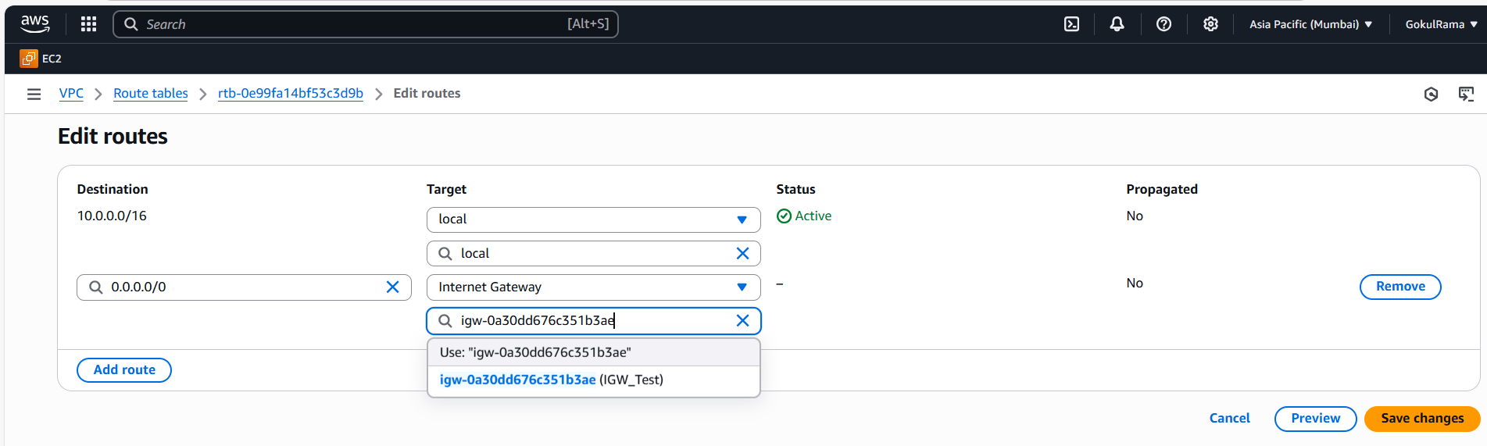

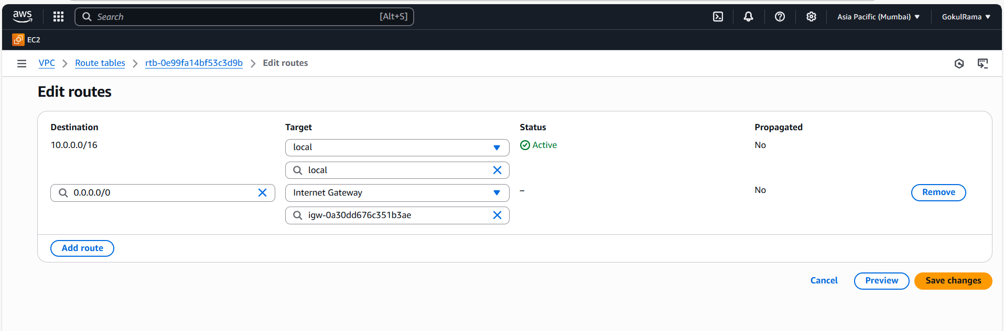

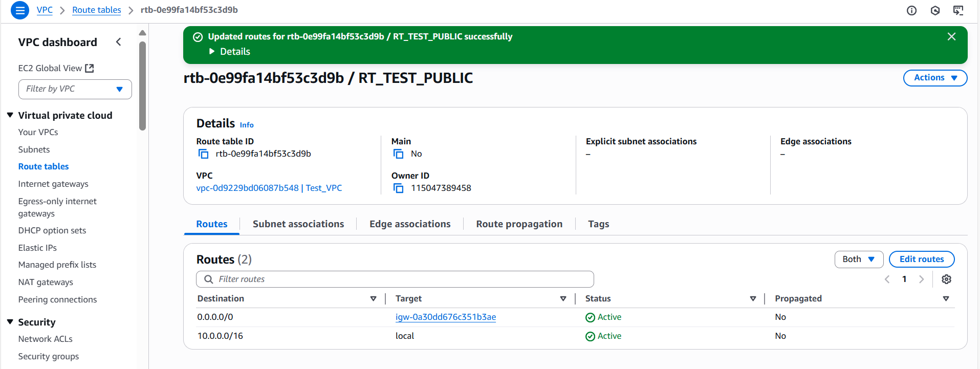

5.4.9 **Once created route, we need to add subnet associations-> Click**

**Edit subnet associations.**

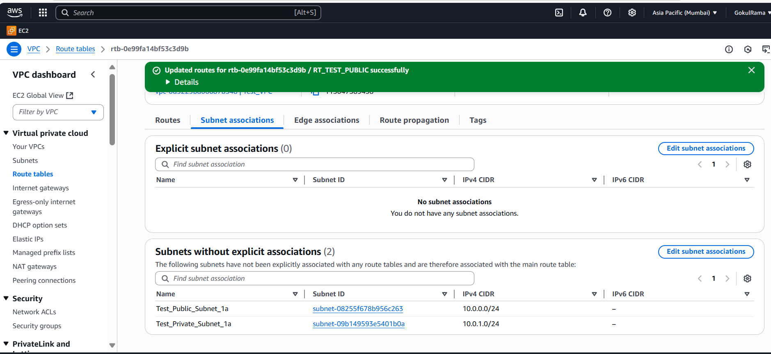

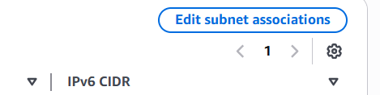

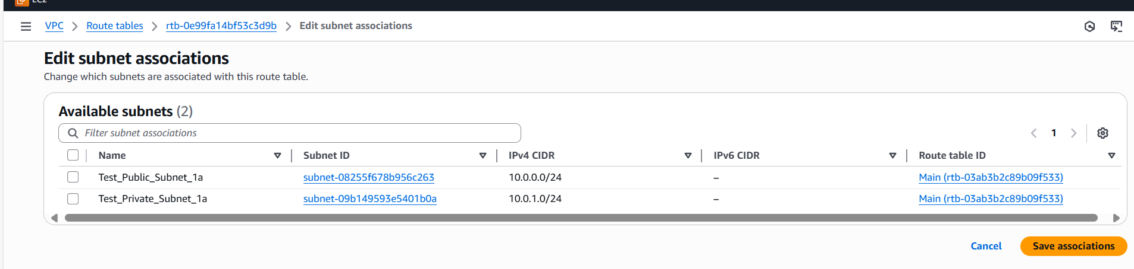

**5.4.10** Select **Public Subnet** andclick **Save associations.**

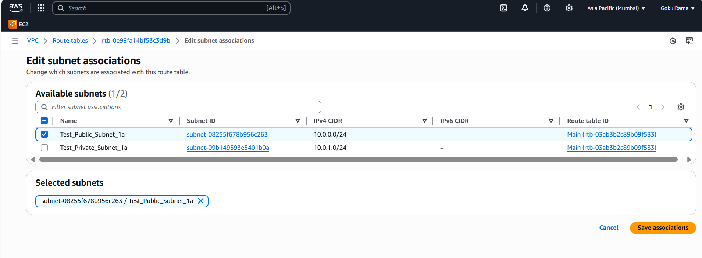

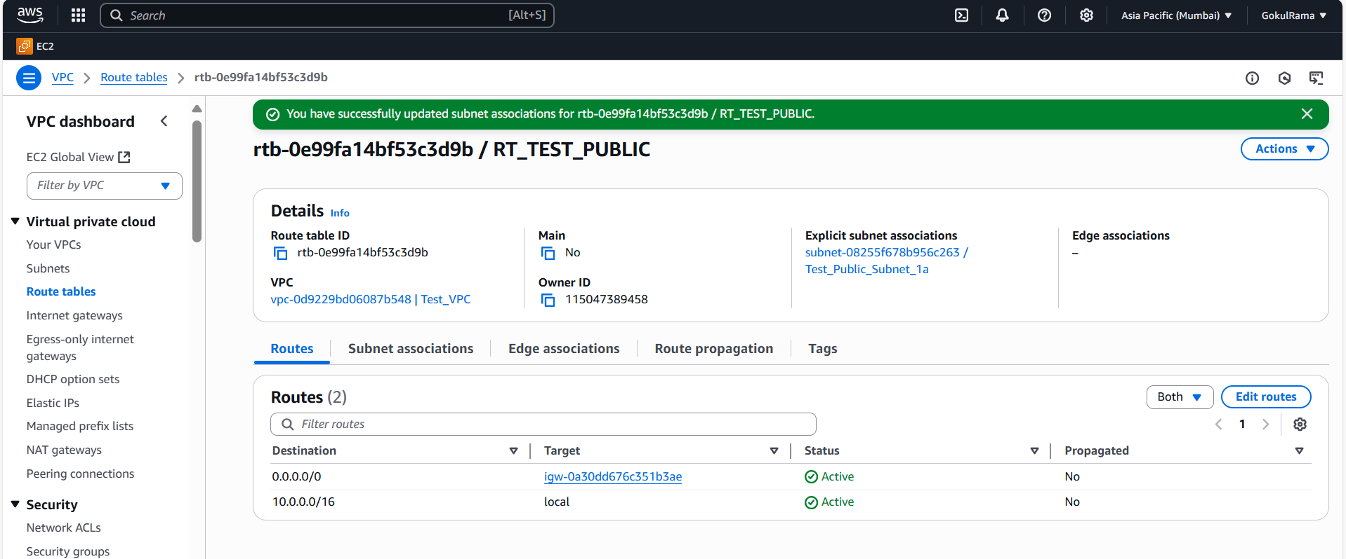

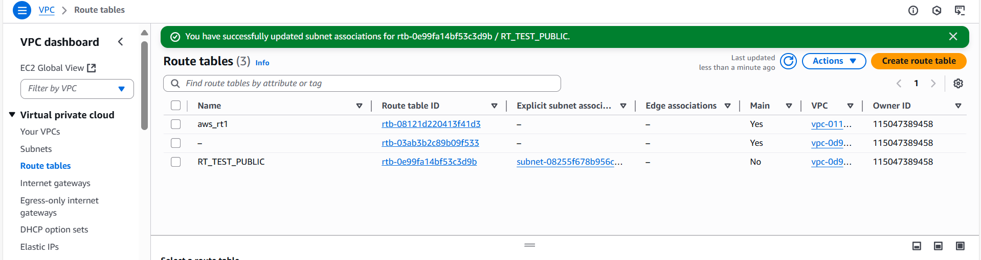

**5.5** Click **Create route table.**

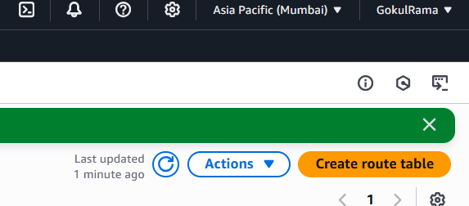

5.6 Once clicked “**Create route table**” and do the below “**Create route table”**

**Settings for private route**,

* + 1. Name of the route table – **RT_TEST_PRIVATE** in **“Name-optional”**
    2. VPC – **Select VPC (Test_VPC)** already created above.
    3. Tags – Give “Route table” name (Name of the route table is **RT_TEST_PRIVATE.**
    4. Click **Create route table.**

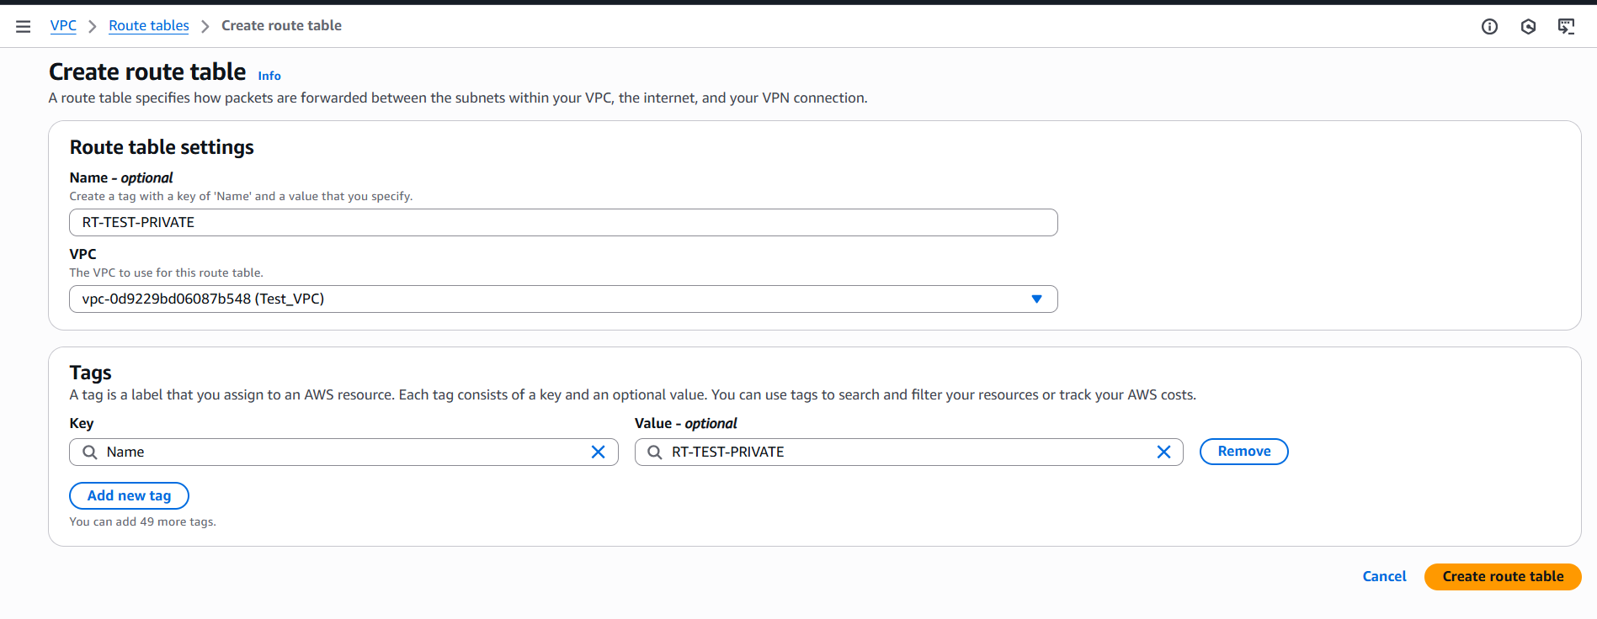

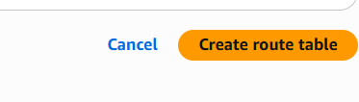

5.6.5 Once private route table created successfully it shown like below,

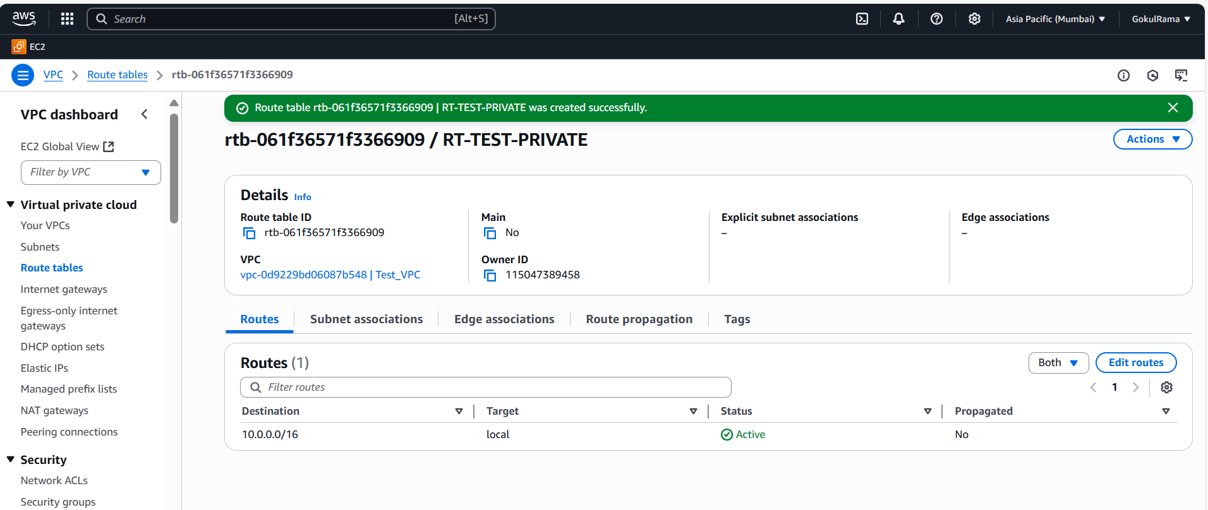

**5.6.6 Once created route, we need to add subnet associations-> Click**

**Edit subnet associations.**

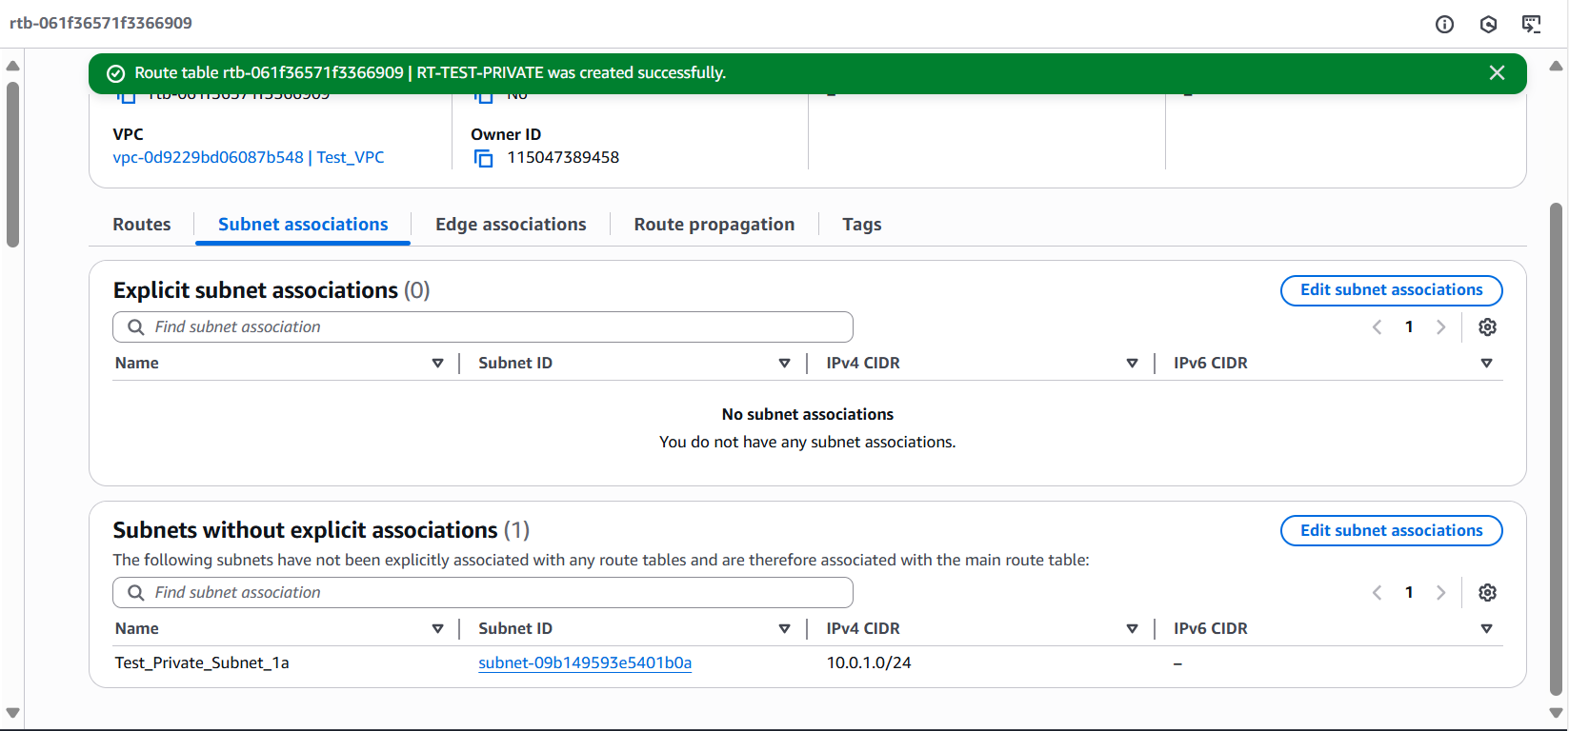

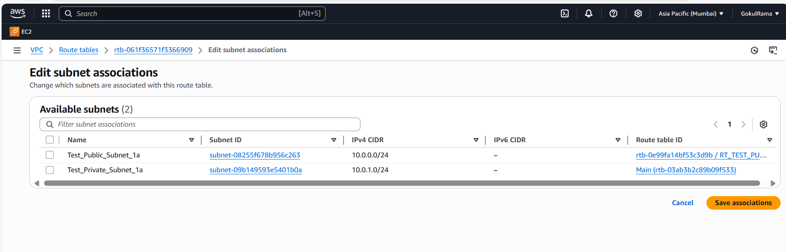

5.6.7 Select **Public Subnet** andclick **Save associations.**

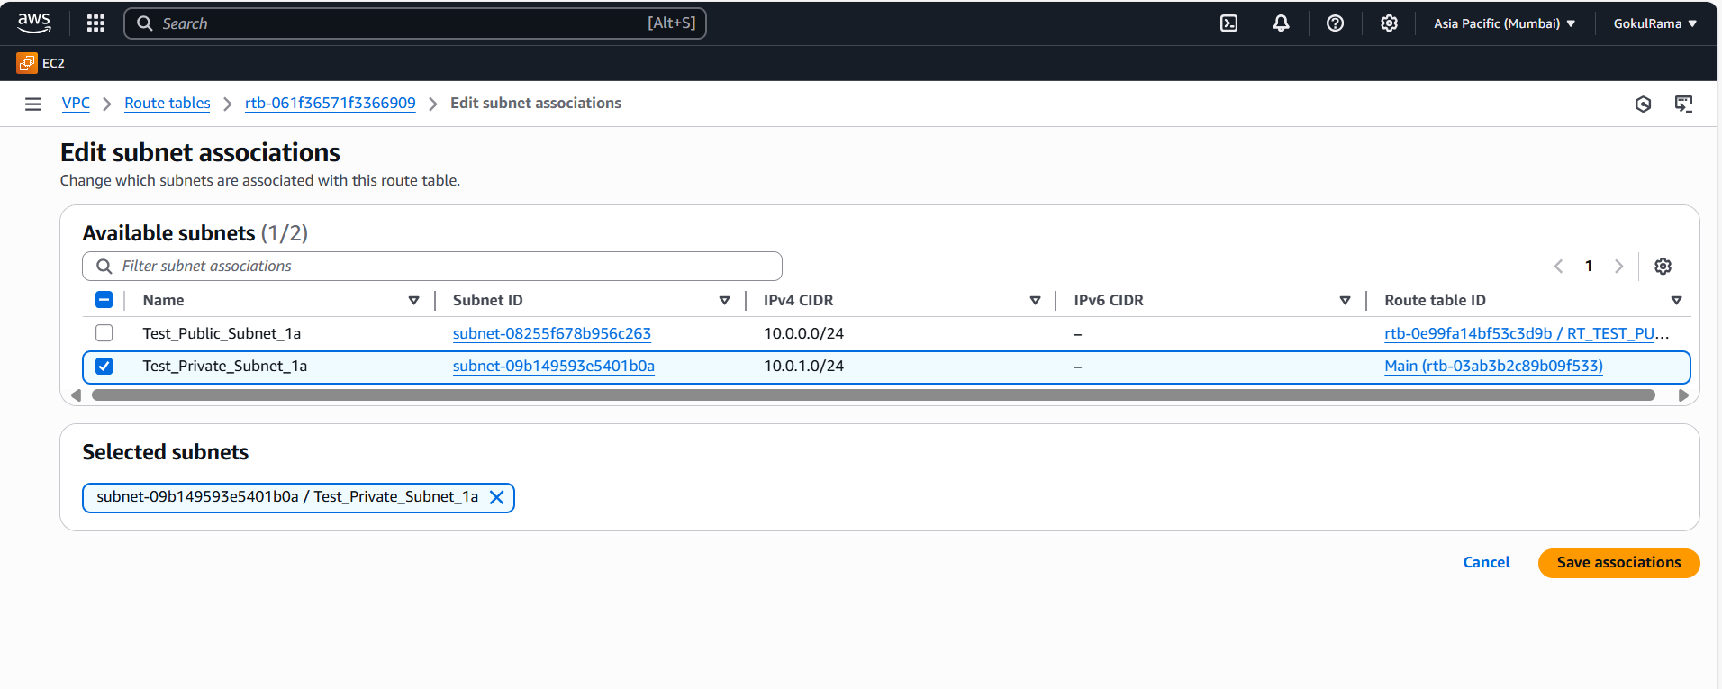

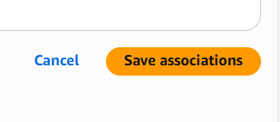

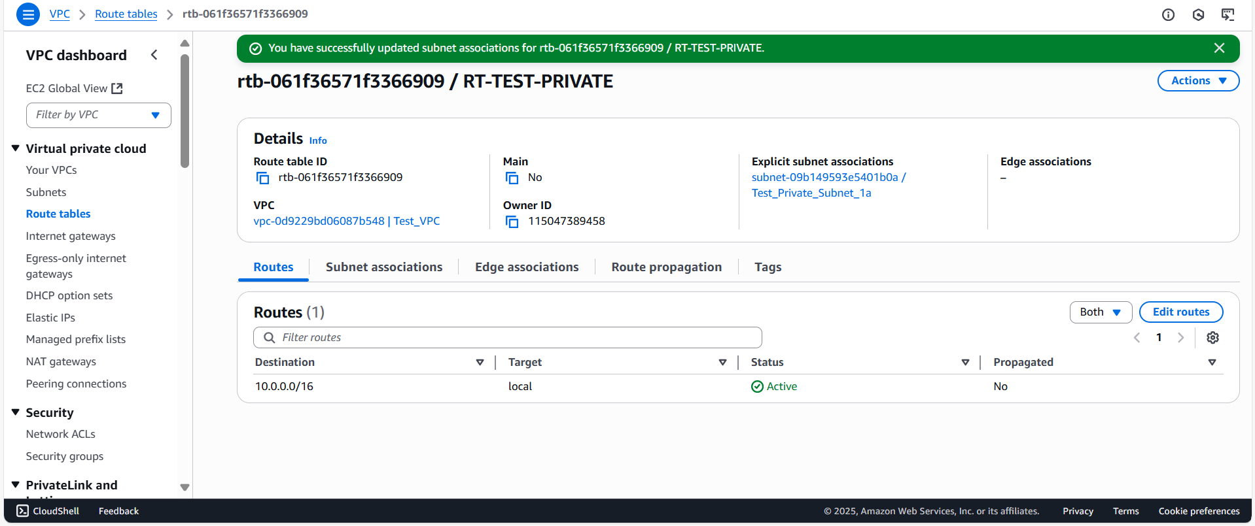

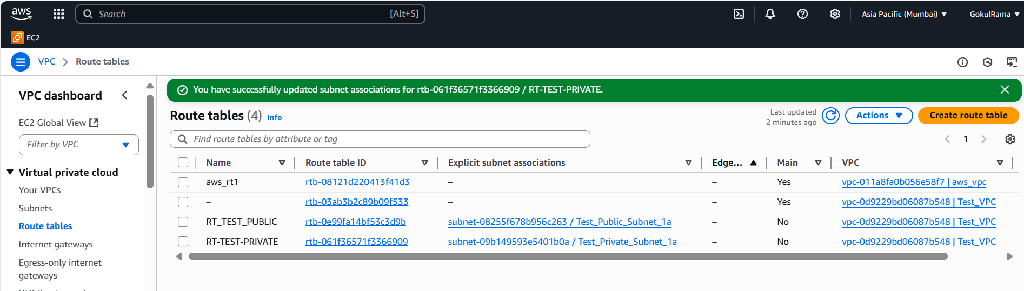

1. **Launching EC2 Instance For Both Public & Private: -**
   1. Search EC2 in search box

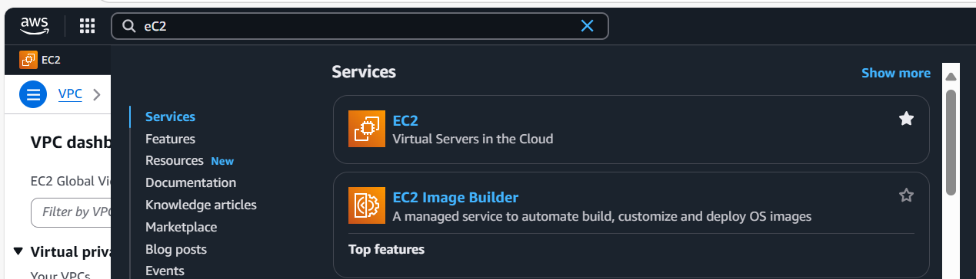

**6.2** Click **Instances** on left side.

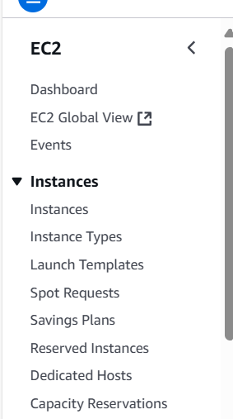

6.3 Select **Launch Instances** option

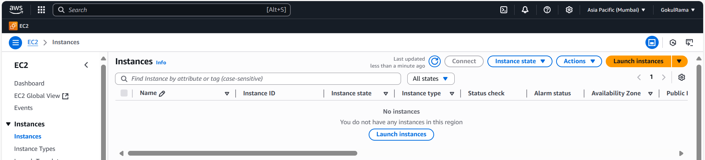

**6.4** Do the below configuration in **Launch an instance** screen

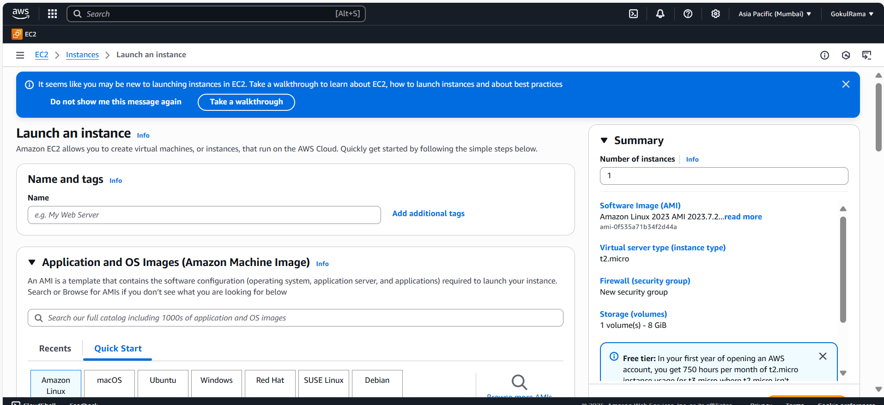

**6.4.1 Name of the instance – EC2-PUBLIC-SUBINSTANCE**

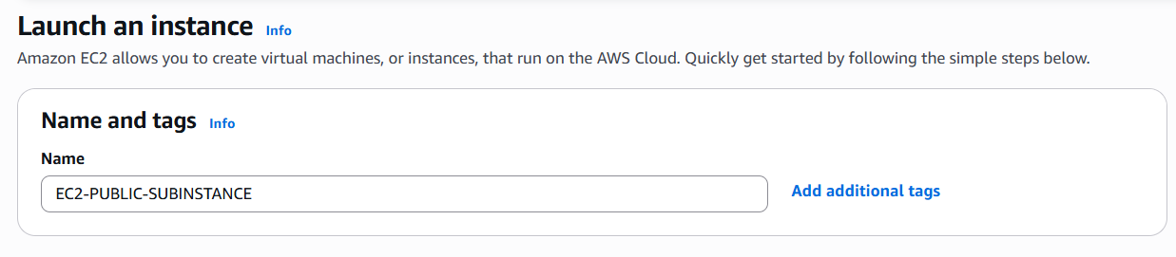

**Select OS – Ubuntu and choose AMI: Ubuntu Server 24.04 LTS (Free tier eligible)**

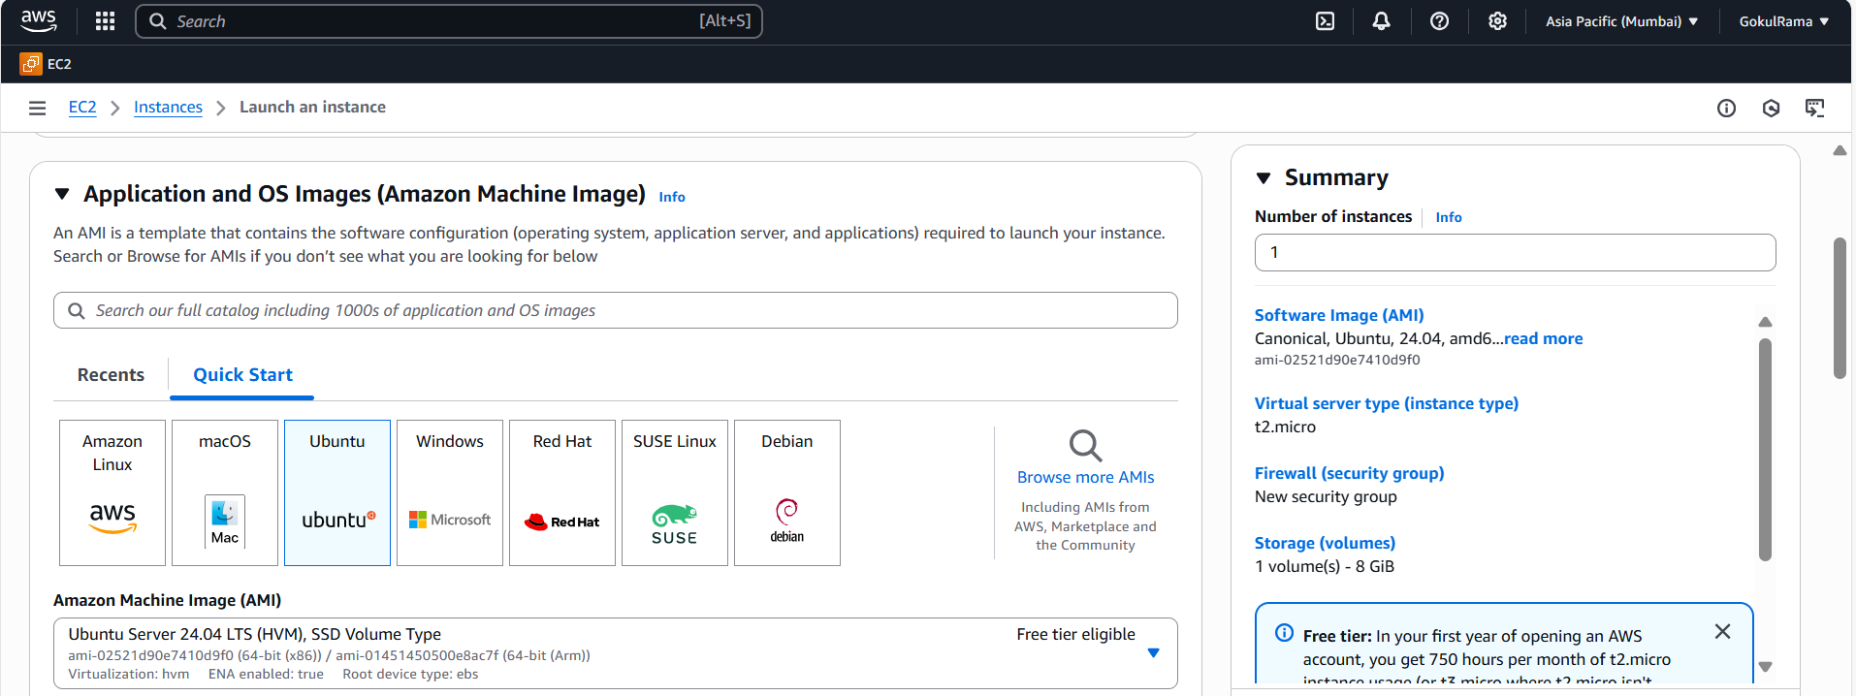

**Choose Instance Type – t2.micro**

**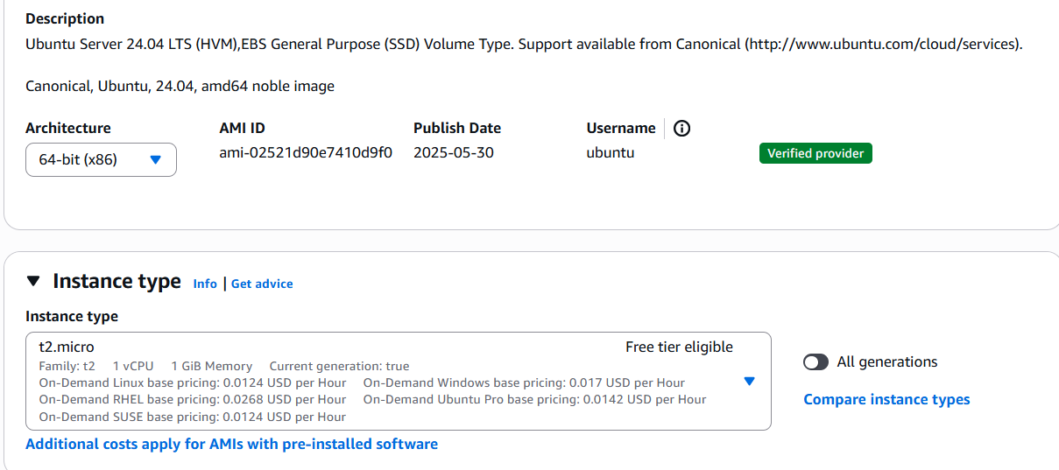  
Choose Keypair (Already generated)**

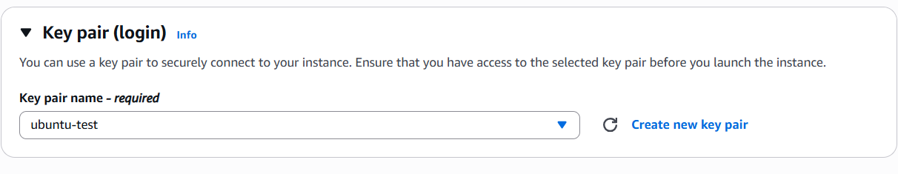

**In Network settings do the below,**

* VPC – required: **Choose VPC (Test_VPC)** that I created above.
* Subnet: Choose **Public Subnet (Test_Public_Subnet_1a)**
* Auto-assign public IP – **Enable**
* Firewall (Security groups) – Choose **Create new security group** option.
* Security group name – required: **Test_EC2_SG**

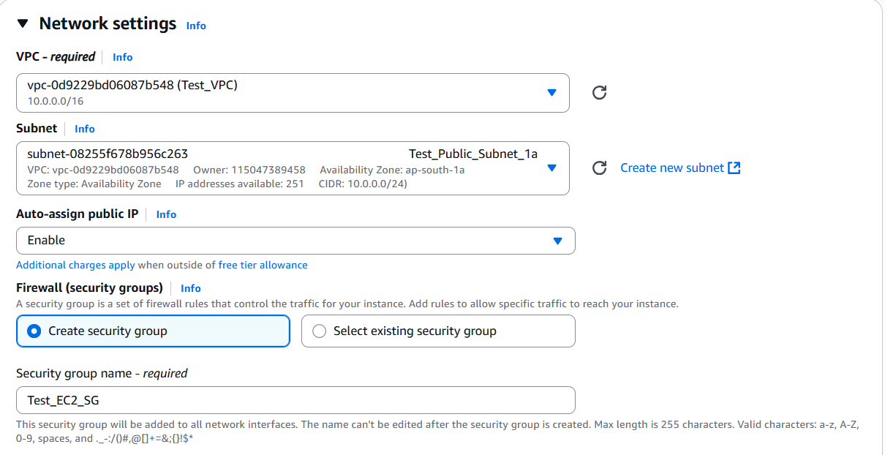

* **Description – required: Give Security group name**
* **Inbound Security Group Rules:**

**Type (SSH) – Protocol (TCP) and Port is 22**

**Source type (Anywhere) – Source (0.0.0.0/0) and Descript**

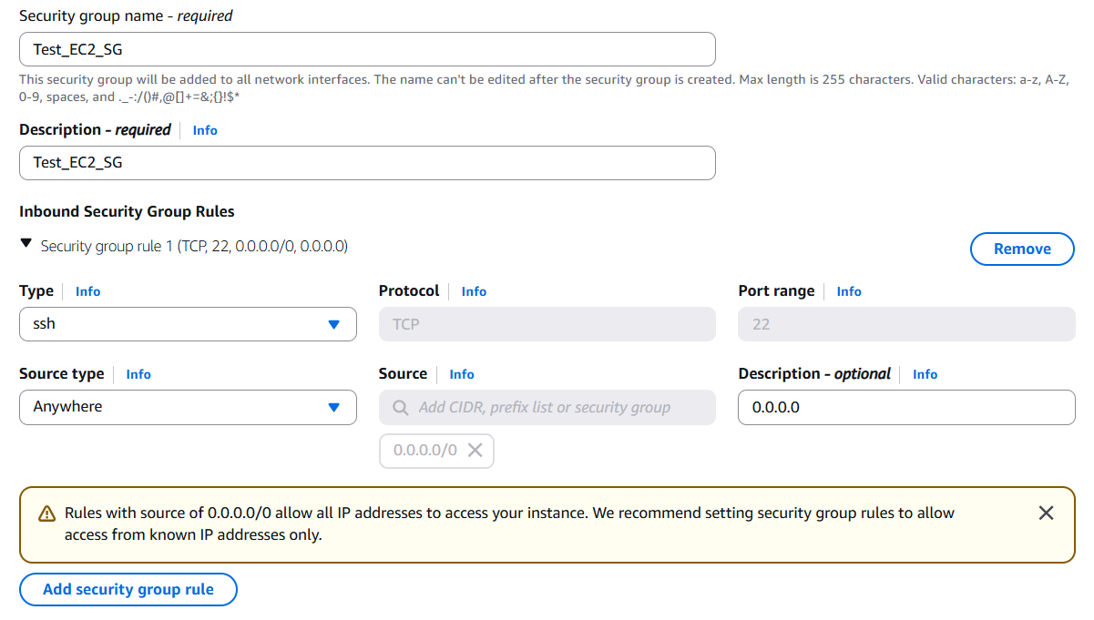

Click **“Launch Instance”** option**.**

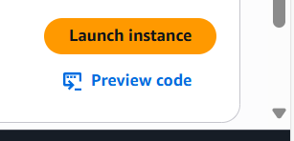

**Once EC2 Public instance launched successfully like below,**

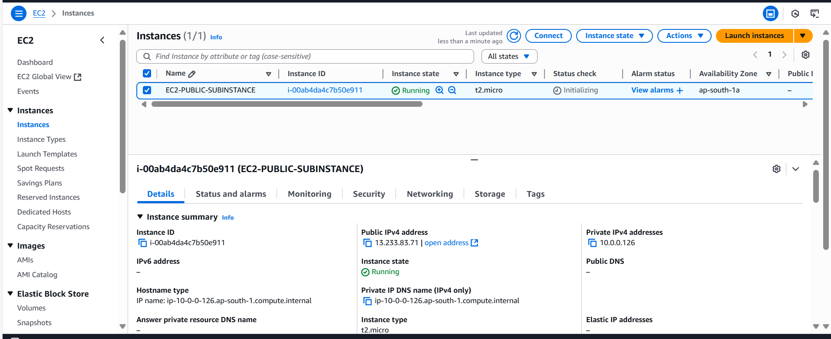

**6.4.2 Launch EC2 instance for Private,**

Name of the instance – EC2-PRIVATE-SUBINSTANCE

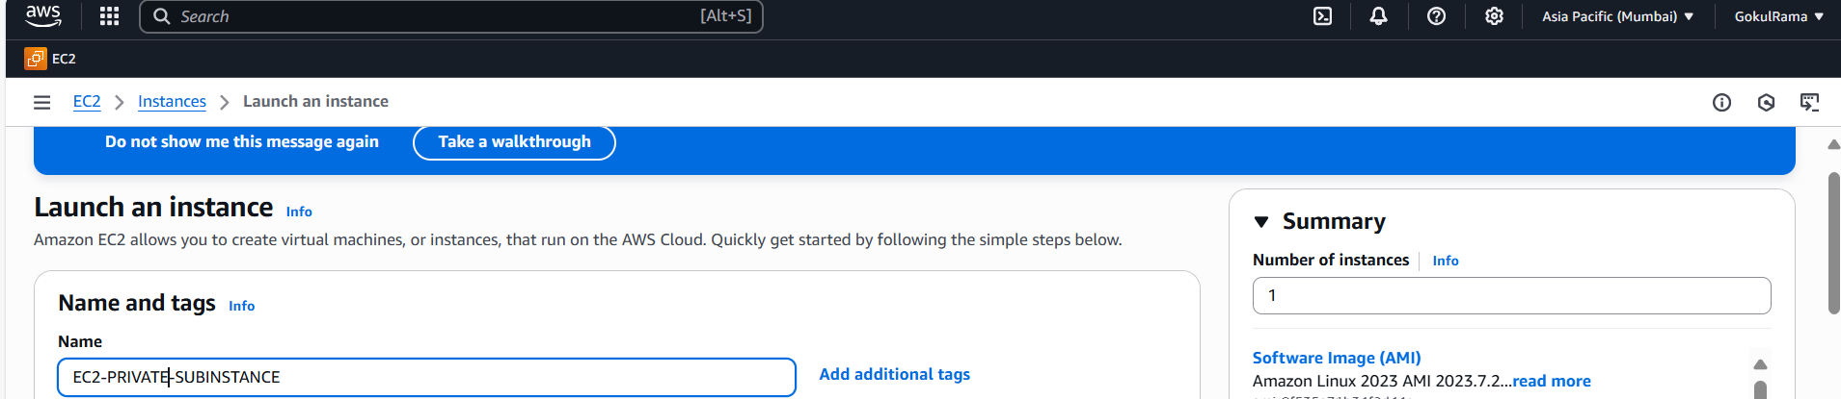

**Select OS – Ubuntu and choose AMI: Ubuntu Server 24.04 LTS (Free tier eligible)**

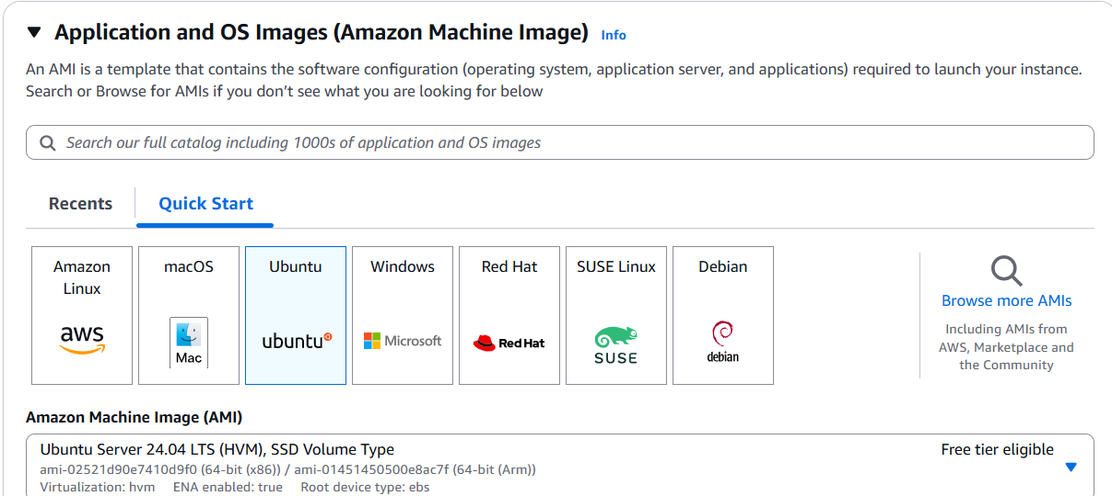

**Choose Instance Type – t2.micro (Free tier eligible)**

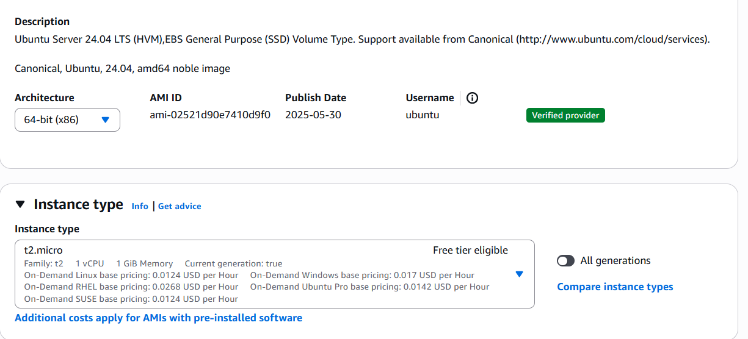

**Choose Keypair (Already generated)**

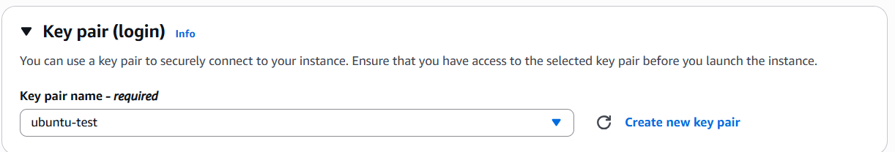

**In Network settings do the below,**

* **VPC – required: Choose VPC (Test_VPC) that I created above.**
* **Subnet: Choose Private Subnet (Test_Private_Subnet_1a)**
* **Auto-assign public IP – Disable**
* **Firewall (Security groups) – Choose select existing security group option.**
* **Common security groups: Choose default security group**
* **Click Launch Instance**

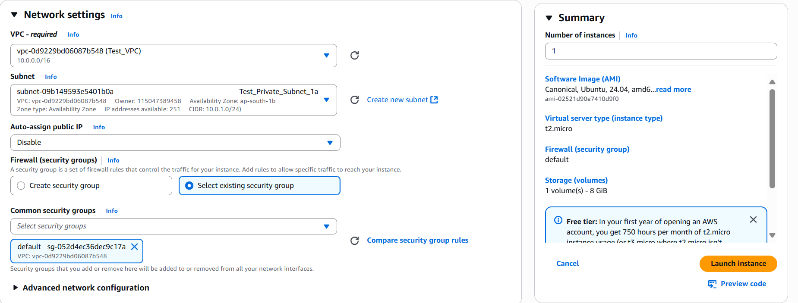

Once Private instance launched successfully (Refer the below snapshot).

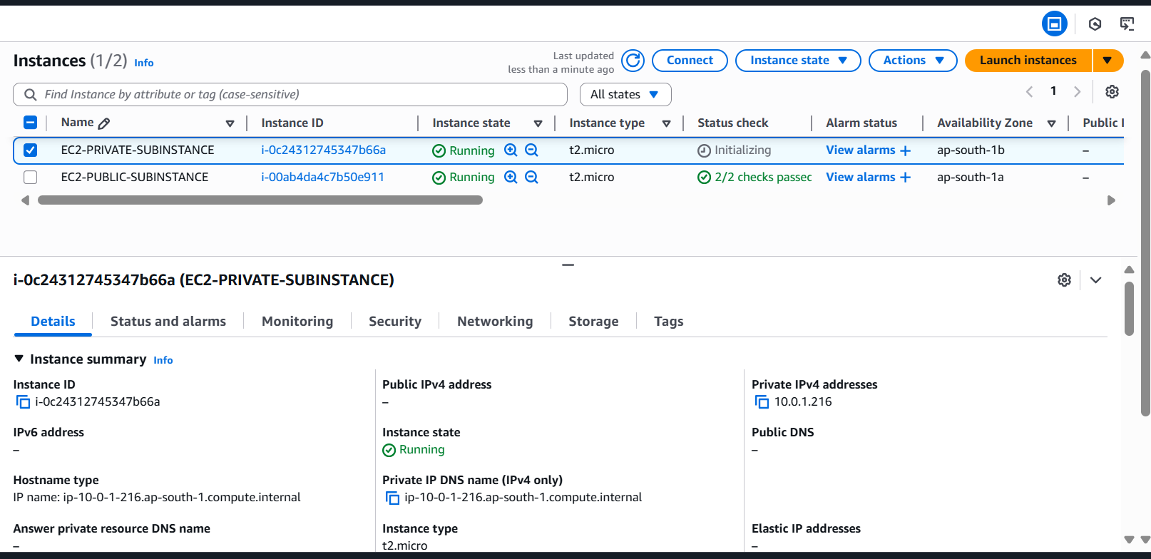

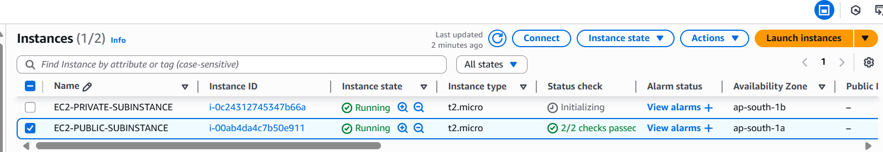

1. **Connect EC2 instance by using above VPC: -**
   1. Select Public EC2 instance -> Click Connect.
   2. Connect by using public IP.

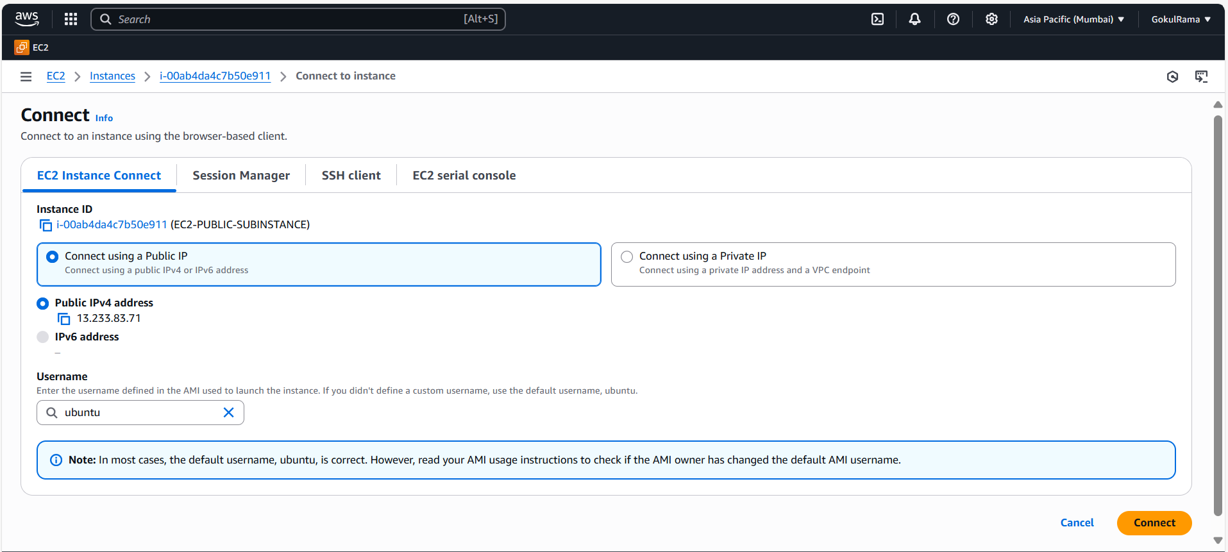

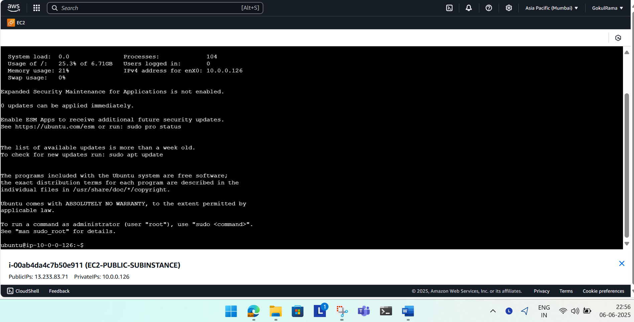

**7.3 Now able to access “google.com” using VPC.**

